Club to increase the attractiveness of the initial discussion, Singapore Malaysia study tour completed

GCMC career manager January 15

On January 8, 2019 to 11, part GCMC organization members participated in the "Singapore and Malaysia club learning", came to Singapore and Malaysia two club learning and communication, how to increase the attraction to the club, keep active members, large-scale activities planning, director of the lawn to cooperation and build the pitch with the general manager and so on were discussed. At the same time, the learning trip will also provide a basis for the upcoming annual meeting, such as learning and communication.

January 8, 2019
At nine o 'clock in the morning, arrived in Singapore Island Country Club members (Singapore Island Country Club -- SICC), in this case, general manager of SICC Desmond Tay (dace, zheng) brought about members keep sharing, zheng always first to introduce the basic situation of SICC SICC is Singapore's largest golf Club, founded in 1963 by the royal merger of Singapore and the royal Island Club, and a total of 81 4.5 18-hole golf course, the membership number is 8000, The number of members reached 18,000.
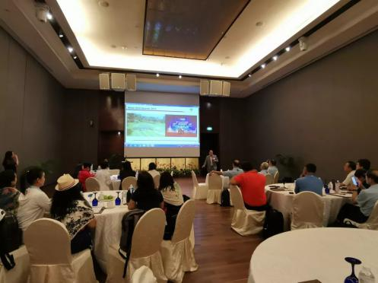

In recent years, some golf clubs in Singapore are facing the issue of the expiry of their land contracts with the government. Whether the clubs can continue to renew their contracts or need to close down has become a matter of concern for them. One of the island club's 18-hole courses is also facing repossession by the government in 2021, so the club is currently in the process of overhauling another 18-hole course - the "new course" - as well as a smaller 9-hole course.

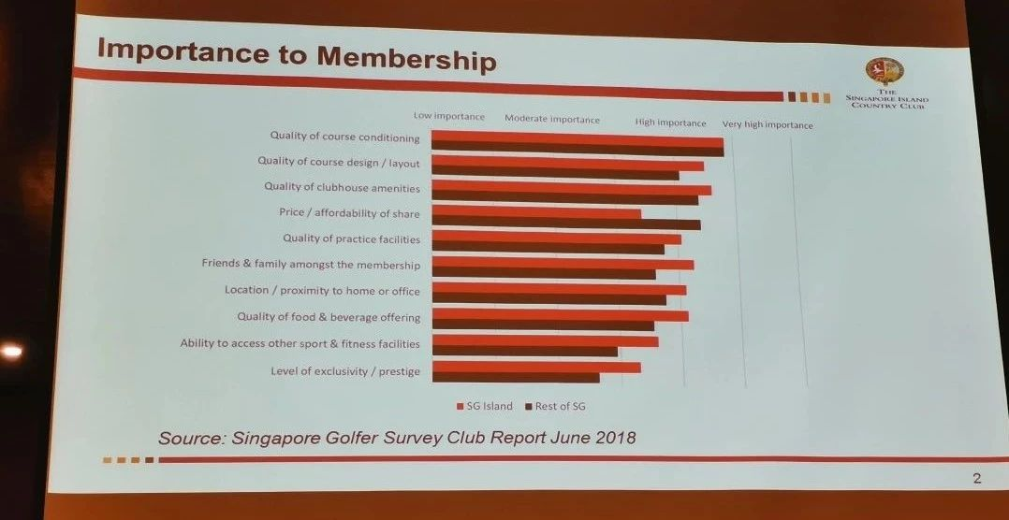
In addition, manager zheng also Shared a survey report on the needs of members for the club, which provided data support for the club to promote the activity of members. The survey of SICC members has also made SICC more aware of its deficiencies in facilities and equipment. Through the survey report, SICC also has more ideas and plans for the renovation of the new club.
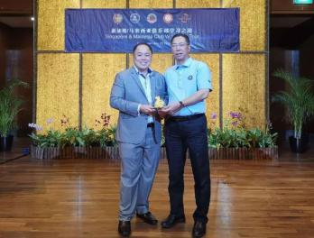

Next, club manager Wendy Tye from SAFRA (Singapore military club) and her colleagues thought about millennials, explaining the current survey data on millennials' interests and hobbies, and how the club is using technology to attract millennials.
Wendy introduced SAFRA's membership activities. As a club with six clubs and more than 40,000 members, they need to plan many activities for members to participate in every year, including marathon, swimming and other sports. Wendy also gave GCMC members ten specific steps in planning the event.

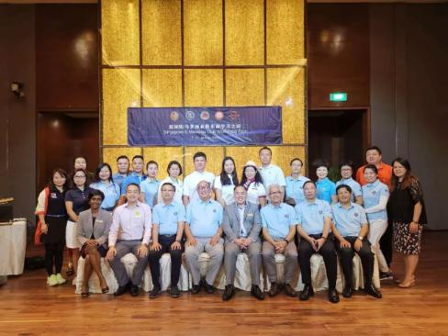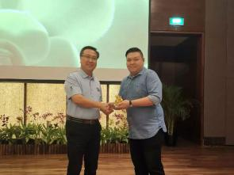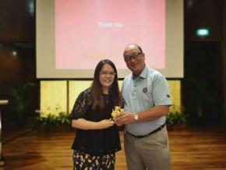

Through the study of a morning, GCMC member of Singapore club also have a certain understanding, Mr Aylwin tai, director and deputy director Mr Zhao Guoxiong also invited the general manager of SICC to GCMC annual meeting this year, and zheng always also should participate in and will be in the meeting with the club general manager of China further discusses the new development direction of the club member and how to improve the viscosity.

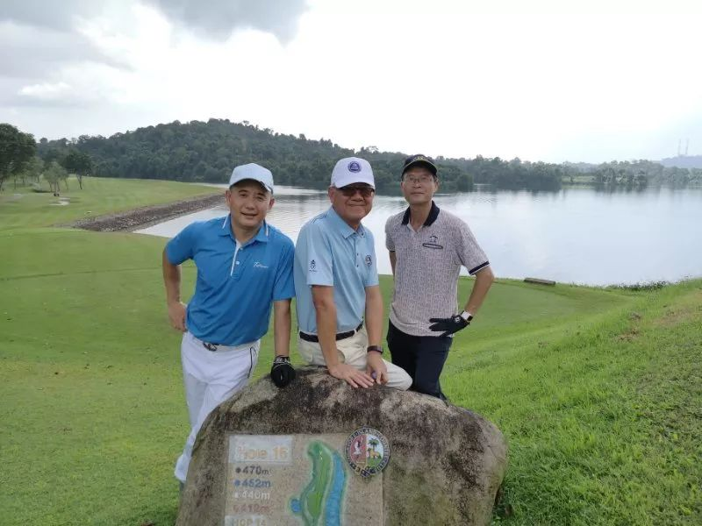

January 9, 2019
In the morning, a group of GCMC members, led by SICC general manager zheng zong, visited SICC's facilities and equipment and learned that bowling and billiards are among the most unpopular sports facilities in the club. The most popular events are: dining, swimming and mahjong.
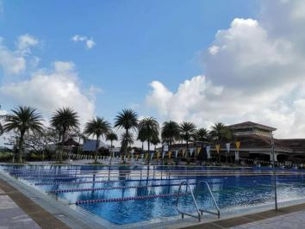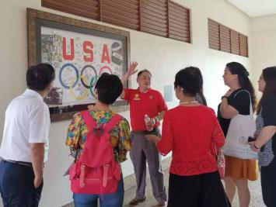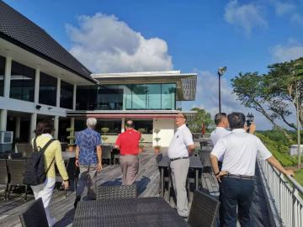

Next, Chris Gray, the lawn director of SICC, shares his thoughts on lawn management and the role of lawn director. From the lawn director's responsibility, how the general manager of the club should communicate with the lawn director, etc.

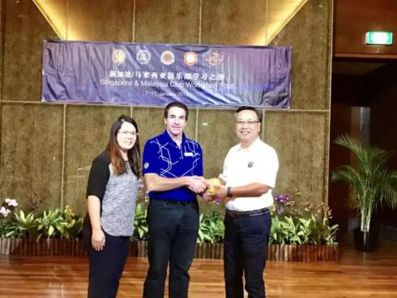

In the afternoon, members said goodbye to SICC and went to Malaysian forest city golf resort. The forest city golf resort is a planned 54-hole golf club. Currently, a Jack Nicklaus 18-hole lakeview golf course has opened in September 2018. Meanwhile, an 18-hole ecological golf course designed by country garden group executive director and group vice President liang guokun is under construction.

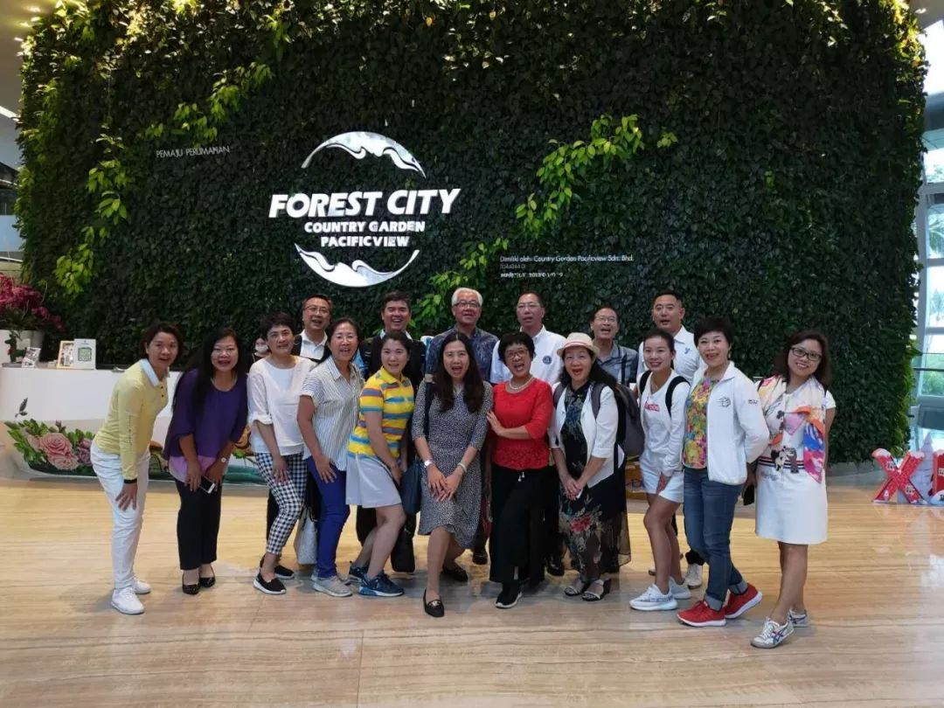

January 10, 2019
In the morning, GCMC members were shown around the golf course under construction, led by director leung kwok-kun, who is also the course's designer.
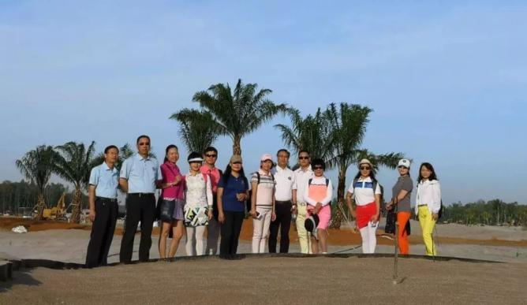

Visit the stadium under construction
After the visit, director leung kwok-kwan Shared the theme of "a sandbar becomes a forest", focusing on the process of the forest city golf resort from a desert and reclamation area to the beautiful golf course today. The careful care for animals and plants in the design and construction also moved the members present.

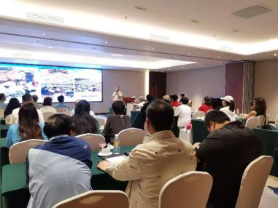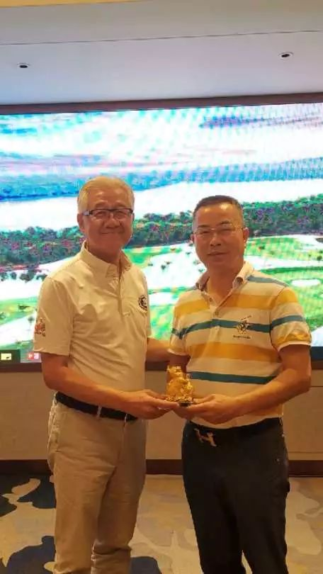

On January 11 members return to their respective, the tour of the new horse believe this journey in addition to club members to Singapore and Malaysia have a certain degree of understanding, at the same time, also will invite Singapore regional club managers in hainan from June the GCMC the fourth session of the general assembly held in shenzhou peninsula, with GCMC members on how to improve the club's current attractive and turn threats into advantages for further discussion, stay tuned.

